**Lenten Customs and Practices**

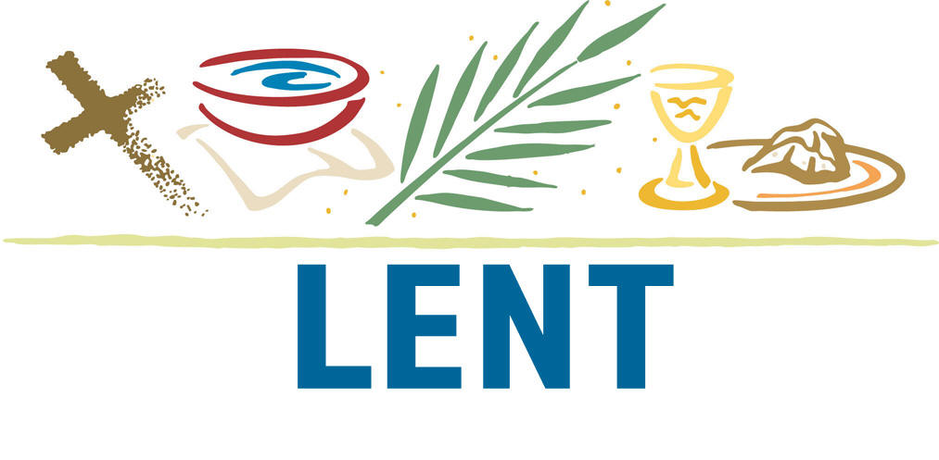

**Lenten Customs and Traditions**

In early centuries, evidence suggests that Christians followed the Jewish custom of Prayer and Fasting for one week before Passover. The first mention of Lent in literature is in 326 C.E.

The Season of Lent was in place in its present form by the fourth century. It spans 40 days (not including Sundays) between Ash Wednesday and concludes the Saturday before Easter. Those 40 days correspond to Christ’s 40 days in the wilderness.

The word ‘Lent’ means ‘lengthen’ and stands for that time in spring when the days grow longer.

The original period of Lent was 40 Hours. It was spent fasting to commemorate the suffering of Christ and the 40 hours He spent in the tomb. From 40 hours it was lengthened to six days, and eventually to the 40 days we now use.

Originally, Lent was the time of preparation for those who were to be baptized, a time of concentrated study and prayer which concluded at the Easter Vigil. Since these new members were to be received into a community of faith, the entire community was gradually called into preparation. This also marked the time when those who had been separated from the church prepared to rejoin the community. Today, Lent is still marked by a time of prayer and preparation leading to Easter.

**Customs**

Penitential prayer, fasting and almsgiving have traditionally marked Lent. Some Christian denominations today still observe a rigid schedule of fasting on certain days during Lent, especially the giving up of meat, alcohol, sweets, and other types of food. Other traditions do not place as great an emphasis on fasting, but focus on charitable deeds, especially helping those in physical need with food and clothing, or simply the giving of money to charities.

However all Christian Churches that observe Lent would focus on it as a time of prayer, especially penance, repenting for failures and for sin as a way to focus on our need for God’s grace. In that sense, it is really a preparation to celebrate God’s redemption at Easter and the resurrected life that Christians live and hope for.



**Carnival**

Carnival which comes from the Latin phrase meaning the removal of meat, is traditionally the 3 day period preceding the beginning of Lent, (in other words the Sunday, Monday and Tuesday immediately before Ash Wednesday). Shrove Tuesday, the day before Ash Wednesday, was so named from the shriving (confession and absolution) of the people in the churches on that day. In England in particular, it became a holiday, in preparation for the Lenten Fast days ahead, when many perishables and dairy products would not be eaten. So, Shrove Tuesday became a day when housewives used their butter and eggs to consume the perishable food in their larders before the fast.

In some parts of England, a Pancake Bell would ring in the morning to show the Holiday had begun and again towards sunset to show that it was over. This day has become more popularly known by its name Mardi Gras (Fat Tuesday), which contrasted with the fasting during Lent. So, Carnival and Mardi Gras are usually a period of celebration, as a festival before fasting during the season of Lent.

One Italian custom for Shrove Tuesday has been to burn all the old junk one had accumulated over the year. In some parts of Italy, the village square still collects the whole community’s discards and rather than have a garage sale, residents simply have a good house cleaning. Old mattresses and chairs are piled with a straw witch, known as La Befana (the old lady of Epiphany). This marked the end of the Epiphany Season, the end of winter, and the beginning of Spring.

On Ash Wednesday, we are signed with the outward sign of our humble beginnings and common end. The Priest puts ashes on our foreheads. This comes from the ancient practice of placing ashes on worshipper’s heads (or foreheads) as sign of humility before God, and as a symbol of mourning and sorrow at the death that sin brings into the world.

*‘Remember that you are dust and to dust you shall return’.*

Ashes are a symbol of penance made sacramental by the blessing of the church to help us develop a spirit of humility ad sacrifice.

The custom is from an old ceremony. Christians who had committed grave faults were obliged to do public penance. On Ash Wednesday the Bishop blessed the hair shirts which they were to wear during the forty days, and sprinkled over them ashes made from the palms from the previous year. Then, while the faithful recited the Seven Penitential Psalms, the penitents were turned out of the Holy Place because of their sins, as Adam, the first man was turned out of paradise on account of his disobedience.

They did not enter the church again until Maundy Thursday after having won reconciliation by the toil of forty days’ penance and sacramental absolution. Later on, all Christians, either public or secret penitents, came out of devotion to receive ashes.

So it not only prefigures the mourning of the death of Jesus, but also places the worshipper in a position to realise the consequence of sin.

The colour used in the Sanctuary of traditional churches for most of Lent is purple or dark violet. These colours symbolize both the pain and suffering leading up to the crucifixion of Jesus, as well as the suffering of humanity and the world under sin. But purple is also the colour of royalty and so anticpates through the suffering and death of Jesus, the coming resurrection that will be celebrated in the resurrection on Easter Sunday.

On mid-lent Sunday, the fourth Sunday in Lent (Mothering Sunday), it was the custom in medieval times, for children away from home to return to visit their parents, and for servants to be given a special holiday for the same purpose. They brought with them posies of flowers for their mothers and simnel cake was eaten at the family meal. The name simnel derives from the latin ‘cimila’ meaning very fine flour.

To help focus on the reality of our need to be transformed, the Church has always suggested a three-fold form of discipline for Lent. Prayer, which is good for the soul, Fasting, for the good of our bodies, and Almsgiving for the good of our neighbor.

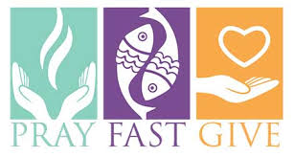

**Prayer**

Drawing close to God in prayer in a state of greater awareness of just how large is the gap separating us from God, is a Lenten tradition of great power. It reminds us all both of the need for a gift as marvelous as Jesus, and also of the cost of the gift.

**Fasting**

Fasting is a form of self-denial, which traditionally involves the limitation of the food we take in or an abstinence from meat. There is however a great difference between dieting and fasting. Dieting is done for health and well-being, but dieting is for self, whereas fasting is self denial and only love can make it a joy.

Fasting (and other forms of self denial), seem easier to undertake if they are dedicated to something or someone beyond the ego. (such as God). Fasting is a form of penance, and has many aspects. It is a way of showing sorrow for our sins. But it is also a way of stripping ourselves of some of the non-essentials of life in order to recognize that which is truly important.

If you have access to the Internet then it is highly probable that you are part of the overfed first world. It is good to remember that we could manage with a lot less food and luxury that we enjoy. We can sometimes fill our lives with material things to the extent that there is little room left for God.

Fasting, whether it be the traditional form of eating less food or in some other form such as giving up some luxury, makes more room for God in our lives.

**Almsgiving**

Almsgiving is a disciplinary form which so often stops at a hasty or half hearted donation, in response to the guilt we feel about the world’s poor and hungry, and an embarrassment of the good things in our own lives. Almsgiving is not meant to simply be charity. Rather, it is a recognition that all we have comes from God. It should be noted that Almsgiving has traditionally been seen as something over and above a tithe that all believers give to God. So, in Almsgiving, the challenge is to be generous.

**Some Possible Lenten Practices**

To give an outward sign to our Lenten efforts, we can make and hang something over the kitchen sink that will make us mindful of our Lenten resolutions. It might be a banner with the three fold theme of Prayer, Fasting and Almsgiving.

A simple cross made of two twigs can be planted in a flower pot as a reminder,’ If anyone loves me let them take up their cross and follow me’. An Alms box, or a tin to collect money for the poor, can be placed in the family home.

Some families have prayers at meals during Lent. God doesn’t need us to pray, fast or give alms – rather we need it to put our fragmented lives back into a single perspective and give us all a new sense of our Christian vocation and responsibility.

**A Season of Joy**

Lent is sometimes seen as a mournful time, but I don’t believe that to be true. The first preface of Lent says ‘Each year you give us this joyful season when we prepare to celebrate the paschal mystery with mind and heart renewed’. By opening our hearts more to God, we will make Lent a truly joyful season.

Lent is a way to place ourselves before God humbled, bringing in our hands no price whereby we can purchase our salvation. It is a way to confess our total inadequacy before God, to strip ourselves bare of all pretense to righteousness, to come before God in dust and ashes.

It is a way to empty ourselves of false pride, of our rationalizations that prevent us from seeing ourselves in need of God. This may put us in a position to hear God in ways that we’ve not heard Him in a long time, and may be the beginning of a healing for which we have so longed.

